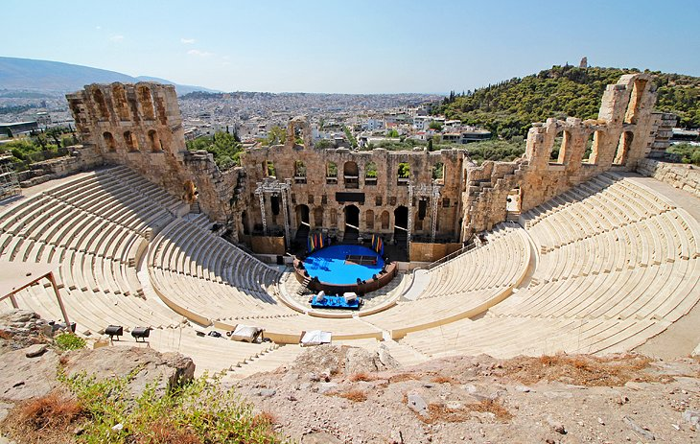
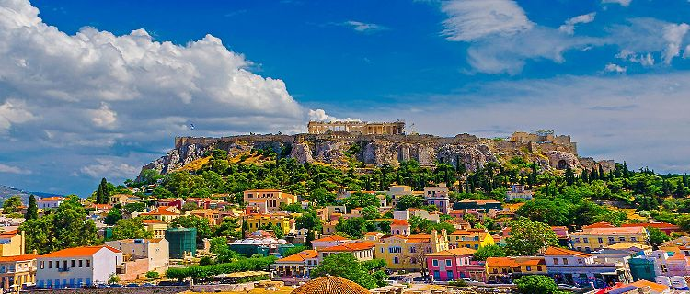

G L O R I O U S G R E E C E
The Cradle Of Western Civilization
September 12 - 22, 2022
Athens, Mykonos, Santorini
$4,799.00 Per Person, Double Occupancy

LAKE ARBOR TRAVEL
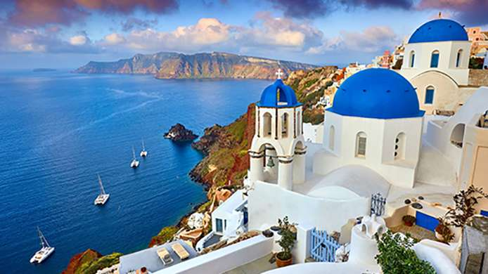
lakearbortravel.com
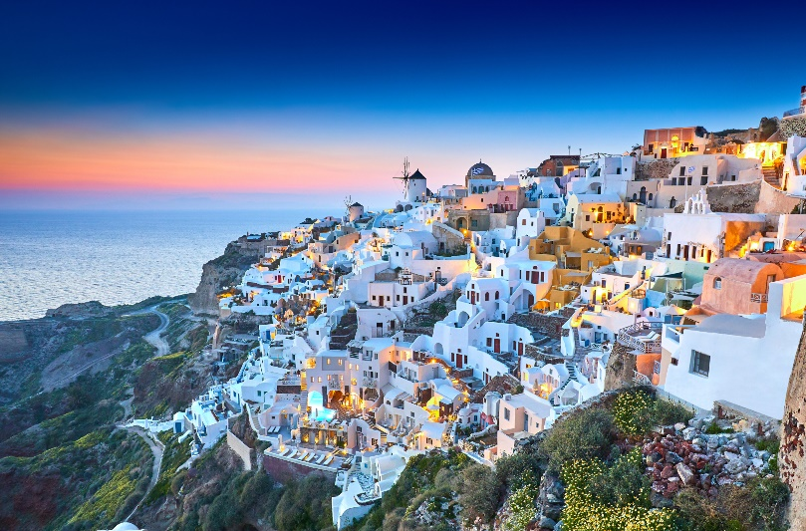
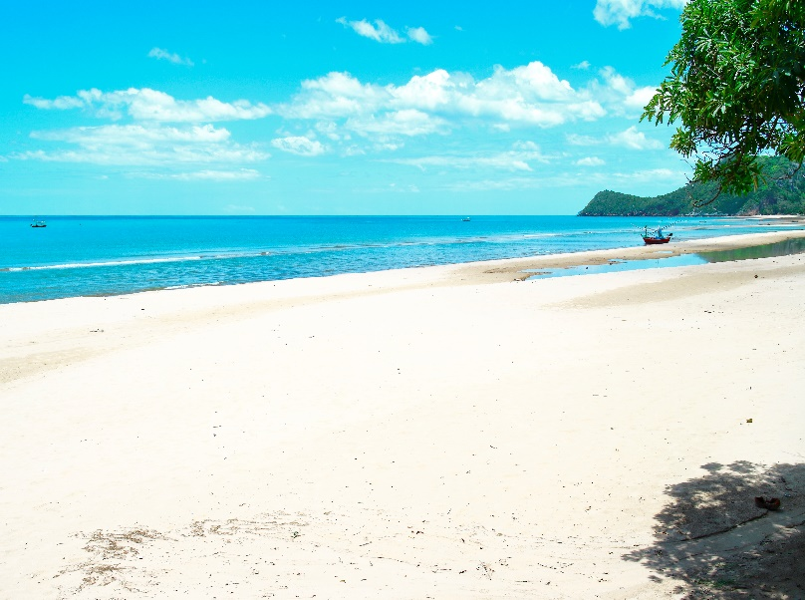
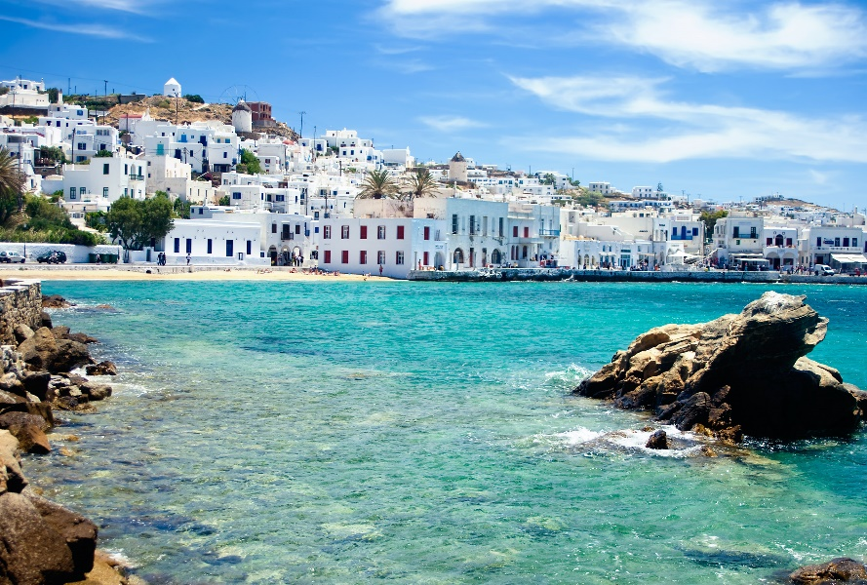

GLORIOUS GREECE

ITINERARY

Monday, September 12: Depart United States
Depart Washington Dulles International Airport on United Airlines, nonstop to Athens, Greece. Flight includes meals, drinks, and in-flight entertainment.

Tuesday, September 13: Arrive Athens, Greece
Arrive Athens International Airport. After clearing Immigration, we will be met and transferred to our deluxe Acropolis View Rooms in The Hotel Stanley, www.hotelstanley.gr, located in central Athens. The Stanley boasts the largest hotel rooftop terrace in Athens, Cloud 9, featuring a pool, bar and open-air restaurant, along with stunning views of the Acropolis, Lycabettus Hill and all of Athens. Afternoon and evening at your leisure. You might want to visit The Plaka, in the shadow of the Acropolis, is a very popular area with sidewalk cafes, tavernas, shops selling jewelry, clothes and local ceramics.
Overnight: The Stanley Hotel

Wednesday, September 14: City Tour of Athens
After breakfast, depart for a City Tour of Athens. This tour gives us the opportunity to observe the striking contrasts that make Athens such a fascinating city. Our expert guide will take you to see the Panathenaic Stadium where the first Olympic Games of modern times were held in 1896. We continue to the Prime Minister’s residence guarded by the Euzones in their colorful uniforms; the Temple of Olympian Zeus; the Hadrian’s Arch; the Parliament and the Memorial to the Unknown Soldier; the Academy; the University; the National Library; and Constitution Square (Syntagma). Visit the Acropolis and see the Architectural Masterpieces of the Golden Age of Athens: The Propylaea, the Temple of Athena Nike, the Erechtheion and, finally, ‘the harmony between material and spirit,’ the monument that ‘puts order in the mind,’ the Parthenon. Lunch at a restaurant in The Plaka.
Meal: Breakfast, Lunch
Overnight: The Stanley Hotel

Thursday, September 15: Arrival and Tour of the Greek Island of Mykonos
After breakfast, we are transferred to the port for a hi-speed hydrofoil ferry to the Island of Mykonos. Upon arrival, we embark on a Tour of Mykonos to view its many white-washed buildings, narrow winding paths and stunning beaches! We will learn about the island’s history, the social customs and see some of the most picturesque landscapes of the Aegean, a real opportunity for photographs. Ag. Gianni, the serene Little Bay with the magnificent views to Delos Island is among our first stops. We visit the beautiful Bay of Ornos, the village of Ano Mera and the interesting Orthodox Monastery of Panagia Tourliani. We continue our way to the beach of Kalafatis with its crystal clear waters. Moving on to Chora, the capital, we have an opportunity to make various stops – at Panormos, Paranga and Super Paradise, the lively beach area, and walk the picturesque streets.

We tour the cosmopolitan port, churches, renowned windmill and Petros the Pelican, the famous pet of the island. The whitewashed windmills line up on a hill overlooking Mykonos Town and are a signature island sight. Lunch at a local restaurant. Then we transfer to our deluxe rooms in a gorgeous seafront hotel, The Petinos Hotel, www.petinoshotel.gr. The Petinos offers you upscale accommodations, modern amenities and impeccable services, including a new starlit swimming pool and ‘puff’ sun loungers. Remainder of the day at leisure.
Meal: Breakfast, Lunch
Overnight: The Petinos Hotel

Friday, September 16: Tour of Mykonos
Full day for leisure and personal activities.
Meal: Breakfast
Overnight: The Petinos Hotel

Saturday, September 17: Day of Leisure
Enjoy our last day in Mykonos – at the beach, partying at Paradise Beach and Super Paradise Beach, visiting the village of colorful Little Venice which literally hangs over the waves of the sea and has been called one of the most charming places on earth!
Meal: Breakfast
Overnight: The Petinos Hotel

Sunday, September 18: Arrival and Tour of The Greek Island of Santorini
After breakfast, we depart the hotel and transfer to the port for the hi-speed hydrofoil ferry to the Island of Santorini. We arrive and depart for a tour of the island. Visually, Santorini is the most spectacular of the Greek Isles. With its brilliant flooded caldera, high cliffs and charming villages, it is the Greek Isle of everyone’s dreams. This tour takes us to Santorini’s highest peak, crowned by the Mount Profitis Ilias Monastery. Here, in this remote spot, we have an ideal photo opportunity to capture the beauty of this ancient island. Discover the village of Pyrgos, which was the capital of Santorini until 1800. After lunch at a local restaurant, we will be transferred to the beautiful El Greco Resort & Spa, www.elgreco.com.gr, offering modern superior accommodations, 5 outdoor pools, 1 indoor pool with bar, restaurant, Lotus Spa and fitness center. Visit the magnificent capital, Fira, a vibrant place full of life and excitement.
Meal: Breakfast, Lunch
Overnight: El Greco Resort & Spa

Monday, September 19: Wine Tasting and Winery Tour, Village of Oia
Santorini is a volcanic island with many wineries. After noon, we visit one of the famous wineries in Santorini, have wine tastings and find out the secrets about the unique way wine is produced on the island. Enjoy tastings of local wine varieties paired with gourmet snacks at the vineyards. After the wine tasting, we will depart for the traditional village of Oia, located on the northern tip of the island, on top of a cliff. The town is filled with whitewashed houses carved into the rugged clifftops and overlooks a vast caldera filled with water. Nearby is the ruined Oia Castle, known for its sunset views.
Meals: Breakfast
Overnight: El Greco Resort & Spa

Tuesday, September 20: Sunset Dinner Cruise
In the evening, depart for a Sunset Dinner Cruise. We sail across the sea route from Ammoudi and Thirassia to Volcano, passing by the gorgeous coastline of southern Santorini with stops for swimming at the Volcanic beaches, Red Beach and Mesa Pigadia. We continue sailing to St. Nikolas and St. Eptapedes in the north. We will have the unique chance to experience the majestic views of the Caldera while enjoying a BBQ dinner and drinks on-board. Impressive pictures, spectacular colors, unmatched beauty of the sun disappearing in the Aegean waters.
Meals: Breakfast & Dinner
Overnight: El Greco Resort & Spa

Wednesday, September 21: Return to Athens
Transfer to airport for a short flight to Athens, arrival and transfer to The Stanley Hotel. See Athens once more and enjoy a Farewell Dinner at a local restaurant in The Plaka.
Meals: Breakfast & Dinner
Overnight: The Stanley Hotel

Thursday, September 22: Depart Athens and Arrive United States
Transfer to the airport at appropriate time for departure to the United States.
Meal: Breakfast

TRAVELERS MUST BE VACCINATED FOR THE CORONAVIRUS

Your Passport Must Be Valid Through March 2023

Included:
Roundtrip Airfare on United Airlines from Washington, D.C. Dulles International Airport
9 Nights Hotel Accommodations
Breakfast, Lunch and Dinner Per Itinerary
Roundtrip Private Airport/Port/Hotel Transfers
Tours Described in Itinerary
English Speaking Tour Guides
Entrance Fees and Tickets Per Itinerary
Hotel Porterage (One Piece Per Person, In/Out)

Not Included:
Gratuities
Meals Not Mentioned
Travel Insurance – www.allianztravelinsurance.com, Travel Agent ACCAM: F030217

Single Traveler Price: $5,999.00

Contact: Toni Hillman, Lake Arbor Travel, tonihillman@aol.com, 301-390-1639,
Text: 240-893-1739 (Please include your name), Website: lakearbortravel.com

A deposit of $1,200.00 per person is due February 15, 2022 to reserve your space; $600.00 is due on
the 12th of the month until balance is paid. Final payment due August 1, 2022.

Cancellation Policy:
Lake Arbor Travel undertakes to protect clients whenever possible from cancellation fees being
enforced, however, the following conditions apply:

$100.00 is nonrefundable; 25% of package price is nonrefundable if canceled within 180 days
of travel; 50% of total package price is nonrefundable if canceled within 90 days of travel;
100% is nonrefundable if canceled within 60 days of travel.

Contact: Toni Hillman, Lake Arbor Travel, tonihillman@aol.com, 301-390-1639,
Text: 240-893-1739, Website: lakearbortravel.com

GLORIOUS GREECE, SEPTEMBER 12-22, 2022
$4,799.00 PER PERSON, DOUBLE OCCUPANCY

-------------------------------------------------------------------------------------------------------------------------------------------------------------------
RESERVATION FORM – Complete and Mail to:

Ms. Toni Hillman, Lake Arbor Travel, 102 Dauntly Street, #100, Upper Marlboro, MD 20774
Please make checks payable to: Lake Arbor Travel

Reserve my space to celebrate: Glorious Greece, SEPTEMBER 12-22, 2022
My deposit of $___________ is enclosed, $1,200.00 per person is required by February 12, 2022)

PLEASE ENCLOSE A COPY OF YOUR PASSPORT PICTURE PAGE
AND CORONAVIRUS VACCINATION CERTFICATE.
E-mail address

Name (As it Appears on Passport) Date of Birth

Street City & State ZIP

Telephone: Home Office Cell

Name of Roommate
Hotel Bedding: ___1 Bed; ___ 2 Beds

